**Mathematical Models – Parametric vs Non-Parametric**

Parametric Models

* Models that are based on common statistical assumptions about the form of the distribution of the data underlying the model.
* This emphasis on assumptions about the data stems from the desire to makie inferences from the data sample such as calculating population parameters, testing hypotheses and constructing confidence intervals which are all facilitated by the use of parametric models.
* These models are commonly used within classical statistics.
* Machine learning can utilise parametric models, especially in situations where interpretability is key, if computational resources are more limited or when the underlying relationships are well understood and can be accurately modelled with parametric models.

Non-Parametric Models

* Models that do not rely on common statistical assumptions about the form of the distribution of the data underlying the model.
* Non-parametric models are commonly used within machine learning, because of their flexibility and ability to model complex relationships without a predetermined equation/function.
* These models are sometimes used within classical statistics, when the assumptions of parametric models are questionable, or where a more flexible approach is required.
* You can use non-parametric models to for hypothesis testing, estimating distributions, and conducting rank-based tests without assuming a specific distribution for the data.

Key Assumptions of Parametric Models

* Form of the Distribution: Many parametric models assume that the data follow a specific distribution, such as the normal (Gaussian) distribution. This is a fundamental assumption because the model's parameters describe characteristics of this distribution (e.g., mean and variance for a normal distribution).
* Independence: It's often assumed that the observations are independent of each other. This means the collection of data points should not influence each other, which is crucial for models like linear regression.
* Linearity: For models like linear regression, there's an assumption of a linear relationship between the independent and dependent variables. This means that changes in the independent variables have a proportional effect on the dependent variable.
* No or Controlled Multicollinearity: In models involving multiple predictors, such as multiple regression, it's assumed that the independent variables are not too highly correlated with each other. High correlation among predictors can make it difficult to determine the individual effect of each predictor on the dependent variable.
* Sample Size: Some parametric models assume that the sample size is sufficiently large to estimate the model parameters accurately. While not an assumption about the data's structure per se, it's a practical consideration for ensuring the reliability of parameter estimates.
* Homoscedasticity: This assumption, particularly relevant in regression models, posits that the variance of the error terms is constant across all levels of the independent variables. In other words, the spread or "scatter" of the residuals (the differences between observed and predicted values) should be roughly equal across all predictions. This means that the size of errors is distributed in a consistent manner across the range of the dependent variable values.

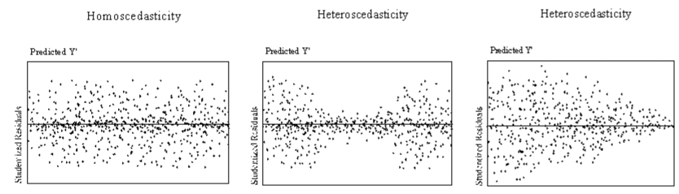

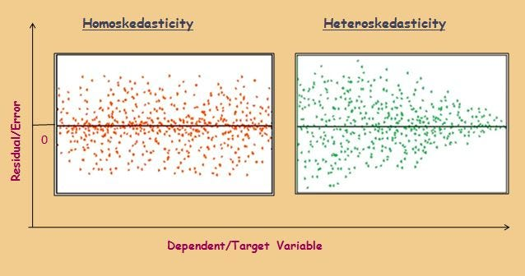

* Error Terms Distribution: Parametric models often assume that the error terms (residuals) follow a normal distribution, especially for inference purposes in regression analysis. This is related to the central limit theorem, which justifies the normality assumption in large samples. This means that there will be more small errors than larger errors, meaning that the error size will be gathered around the mean (ie. the regression line).

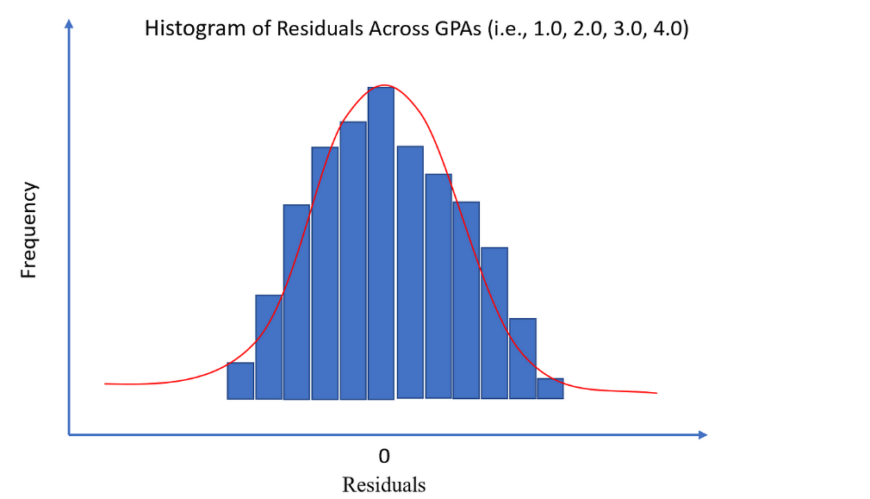

When these assumptions are not met, the conclusions drawn from parametric models might be invalid or misleading. In such cases, analysts might need to transform the data to better meet these assumptions, choose a different parametric model that has assumptions more aligned with their data, or opt for non-parametric models that are less restrictive in their assumptions.